

Project Report On

“REALIZATION OF AN EMBEDDED MQTT BROKER SUPPORTING DETERMINISTIC QoS SCHEDULING”
Submitted in partial fulfillment of the requirements for the
V semester
Mini Project Work [213ECE2363]
Bachelor of Engineering In
Electronics and Communication Engineering
Of
Kalasalingam Academy of Research and Education By

Pothuri Preethika (9924005204)
M. Sunitha (9924005308)
B. Mathesh (9924005435)
Kadamanchi Dinesh(9924005335)
Department of Electronics and Communication Engineering Kalasalingam Academy of Research and Education
2026-2027
Kalasalingam Academy of Research and Education Krishnankoil, Srivilliputhur, Tamil Nadu 626126 Department of Electronics and Communication Engineering

CERTIFICATE
It is Certified that Pothuri Preethika, M. Sunitha, B. Mathesh and Kadamanchi Dinesh bearing REG NUM:9924005204,9924005308,9924005435,9924005335 respectively, are bonafide students of Kalasalingam Academy of Research and Education, and have completed requirements of the project entitled “Realization of an Embedded MQTT Broker Supporting Deterministic QoS Scheduling” partial fulfillment of the requirements for V semester Bachelor of Engineering in Electronics and Communication Engineering during academic year 2026-27. It is certified that all Corrections/Suggestions indicated for Project Assessment have been incorporated in the report. The project report has been approved as it satisfies the academic requirements in respect of project work Phase-2 prescribed for the Bachelor of Engineering degree.

Mr. Bhargav- Senior design engineer. Mrs. Loyola Jasmine J
External Guide Internal Guide
Company - Simask Pvt Ltd Assistant Professor Dept. of ECE,KARE

External Viva
Name of the Examiners Signature with date

DECLARATION

It is Certified that Pothuri Preethika, M. Sunitha, B. Mathesh and Kadamanchi Dinesh bearing REG NUM: 9924005204,9924005308,9924005435,9924005335 respectively, are bonafide students of Kalasalingam Academy of Research and Education, and have completed requirements of the project entitled “Realization of an Embedded MQTT Broker Supporting Deterministic QoS Scheduling” partial fulfillment of the requirements for V semester Bachelor of Engineering in Electronics and Communication Engineering during academic year 2026- 27.

We also declare that, to the best of our knowledge and belief, the work reported here does not form part of any other report on the basis of which a degree or award was conferred on an earlier occasion on this by any other student.

Date:

Place:

ABSTRACT

The Internet of Things (IoT) connects sensor devices, embedded controllers and software platforms so that information can be shared and acted upon in a timely manner. In systems where multiple sensor nodes publish data, messages may not all have the same urgency. A monitoring system therefore needs a clear way to classify incoming messages and decide which messages should be handled first.
This project, titled “Realization of an Embedded MQTT Broker Supporting Deterministic QoS Scheduling,” develops a prototype communication and monitoring pipeline using two ESP32 sensor nodes, an MQTT broker, a Python-based priority scheduler, an STM32 NUCLEO-F446RE development board and a Firebase-connected web dashboard. One ESP32 node publishes TDS sensor readings to the topic sensor/tds, while the second publishes water-sensor readings to sensor/water2. The MQTT broker is hosted on a laptop using Mosquitto.
A Python subscriber receives the published messages, applies prototype threshold rules and assigns a priority label. In the current implementation, readings at or above the configured threshold are marked CRITICAL with priority 1; other readings are marked NORMAL with priority 2. The scheduler uses a priority queue approach and forwards status information to the STM32 through UART. The Python application also uploads sensor readings and related status fields to Firebase Realtime Database. A React and Vite dashboard displays live sensor values, logs and priority-related information.
The current prototype demonstrates sensor-message reception, priority classification, Firebase data updates and dashboard connectivity. Testing logs also show that the STM32 communication path can encounter queue-full responses and acknowledgement timeouts under repeated message transmission. In addition, the dashboard does not yet display independently verified STM32 processing order or acknowledgement history. These points are treated as known limitations rather than hidden. The project provides a practical foundation for further work on queue management, reliable UART communication and measurable scheduling performance.
Keywords: MQTT, ESP32, Mosquitto, Python, Priority Scheduling, STM32, UART, Firebase Realtime Database, React Dashboard

Contents

Chapter 1: Introduction Chapter 2: Case study
Chapter 3: Methodology Chapter 4: Literature Survey Chapter 5: Implementation
Chapter 6: Flow chart/Algorithm
Chapter 7: Simulation/result analysis Chapter 8: Conclusion and Future Scope Chapter 9: References

CHAPTER-1 INTRODUCTION

Background
IoT applications often use several small devices to collect information from their surroundings. These devices may publish readings at different times and at different rates. MQTT is a lightweight publish–subscribe messaging protocol commonly used for communication between constrained devices and networked applications. A publisher sends a message to a topic, and subscribers that have subscribed to that topic receive the message through the broker.
In a multi-sensor system, every message may not have the same importance. For example, a reading that crosses a configured alert threshold may need attention before an ordinary reading. If all messages are handled in the same order in which they arrive, an urgent message may wait behind less important messages. This project explores a separate priority-scheduling layer alongside MQTT communication.

Problem Statement
The project addresses the need to receive messages from multiple sensor nodes, classify them according to configurable urgency rules, and forward the resulting status to an embedded controller while maintaining a cloud-connected record. The prototype must also make the sensor data and assigned priority visible through a dashboard. The key engineering challenge is to coordinate message reception, priority handling, UART transfer and cloud updates without assuming that successful cloud display automatically proves successful embedded-controller processing.

Objectives
    - Establish MQTT communication between two ESP32 sensor nodes and a Mosquitto broker.
    - Publish TDS and water-sensor readings on separate MQTT topics.
    - Receive sensor messages in Python and classify them using configurable prototype thresholds.
    - Use a priority-queue-based scheduling approach to organise messages for forwarding.
    - Send status information from the Python application to an STM32 NUCLEO-F446RE board through UART

.
    - Store sensor readings, status and priority-related information in Firebase Realtime Database.
    - Display live sensor information, logs and priority assignment in a React-based dashboard.

Scope
The present scope is a working prototype for two sensor streams. The project demonstrates MQTT message flow, threshold-based priority assignment, cloud data updates and dashboard visualisation. The current UART message sent to the STM32 is the status string CRITICAL or NORMAL; raw sensor values are not described as being processed by the STM32. The prototype thresholds are software settings used for demonstration and are not certified safety or water-quality limits
.

Organisation of the Report
Chapter 2 describes the use case and system requirements. Chapter 3 explains the architecture and data flow. Chapter 4 summarises the technical concepts and documentation relevant to the design. Chapter 5 records the implementation. Chapter 6 presents the algorithm and flow. Chapter 7 discusses observed results
and limitations. Chapter 8 concludes the work and identifies future improvements.

CHAPTER-2
CASE STUDY

Application Scenario
Consider a monitoring setup with two sensor nodes reporting measurements to a central application. The first node reports TDS readings and the second reports a water-sensor reading. Both nodes communicate over Wi-Fi using MQTT. The central application receives messages from the broker, evaluates each reading against a configured threshold and labels it as CRITICAL or NORMAL.

Existing Approach and Need
A basic MQTT subscriber can receive messages and store them, but it does not automatically implement the application-specific priority policy required by this project. The project therefore places a Python scheduling layer after message reception. This separates message transport from the decision about which received message should be handled first.

Proposed System
The proposed prototype combines an MQTT broker with a priority-classification and scheduling application. Firebase provides a cloud data store for the dashboard, while the STM32 board is used as an embedded endpoint for receiving status messages over UART. The dashboard provides a convenient view of sensor values, logs and assigned priorities.

Functional Requirements

ID | Requirement
FR1 | Receive MQTT messages from both sensor topics.
FR2 | Read the sensor identifier and value from each message.
FR3 | Assign CRITICAL / priority 1 or NORMAL / priority 2 using configured rules.
FR4 | Place received items into the scheduler's priority queue/batch process.
FR5 | Forward the status to STM32 over UART.
FR6 | Upload sensor and status information to Firebase.
FR7 | Display live values, logs and priority information on the dashboard.

Non-Functional Considerations
The design should be understandable, modular and maintainable. Message handling should avoid unnecessary blocking, and communication failures should be visible in logs. The system should also protect credentials and network details. The current prototype has identified UART queue capacity and acknowledgement handling as areas requiring further improvement

CHAPTER-3 METHODOLOGY

Overall Architecture
The system is organised into five functional stages: sensor publishing, MQTT message transport, Python-side classification and scheduling, embedded-controller communication, and cloud storage/dashboard display. Each stage has a separate responsibility.

Stage | Module | Role
1 | ESP32 sensor nodes | Read sensors and publish MQTT messages.
2 | Mosquitto broker | Receive publications and deliver them to subscribers.
3 | Python subscriber and scheduler | Parse messages, assign priority and organise forwarding.
4 | STM32 NUCLEO-F446RE | Receive status strings through UART.
5 | Firebase and React dashboard | Store and present readings, logs and priority information.

Sensor Nodes and Topics
ESP32 Node 1 is connected to the TDS sensor and publishes to sensor/tds. ESP32 Node 2 is connected to the water sensor and publishes to sensor/water2. The two topics keep the streams distinguishable at the broker and subscriber.

MQTT Communication
MQTT follows a publish–subscribe model. The ESP32 devices act as publishers, the Mosquitto service acts as the broker, and the Python program acts as a subscriber. The broker is configured on the local network at port 1883. The project setup used a broker host address of 10.60.111.70. This is a local network address and may change when the network changes.

Priority Classification
The current prototype applies the following software rules:

Sensor stream | Condition | Status | Priority
TDS | Value  100 | CRITICAL | 1
TDS | Value < 100 | NORMAL | 2
Water sensor | Value  1 | CRITICAL | 1
Water sensor | Value < 1 | NORMAL | 2

These values are prototype thresholds used by the current software. They must not be interpreted as validated TDS or water-quality standards. Thresholds should be calibrated and justified for the intended application before operational use.

Scheduling and UART
The Python application uses a priority-queue approach based on Python's heapq facility and processes messages in batches. The batch interval recorded for the prototype is 20 seconds. The application sends a
status string, either CRITICAL or NORMAL, to the STM32 over a serial UART connection configured at 115200 baud on COM7 in the reported setup. The STM32 response is read and recorded by the Python application.

Firebase and Dashboard
The Python application uses the Firebase Admin SDK to update Firebase Realtime Database records. The reported data paths include sensors/tds/latest, sensors/water2/latest and sensor_logs. The React and Vite dashboard connects to Firebase and presents current sensor values, logs and priority-related fields.

Development Tools
    - ESP32 development environment: Thonny with MicroPython (as used in the project workflow).
    - MQTT broker: Eclipse Mosquitto.
    - Subscriber and scheduler: Python, MQTT client library and heapq.
    - Embedded endpoint: STM32 NUCLEO-F446RE board.
    - Serial communication: UART at 115200 baud in the reported test setup.
    - Cloud database: Firebase Realtime Database with Firebase Admin SDK.
Dashboard: React and Vite with Firebase web integration.

CHAPTER-4 LITERATURE SURVEY
This chapter records the technical foundations used to design the prototype. It is a concept-focused survey rather than a claim that a particular published research paper has been experimentally reproduced.

MQTT Publish–Subscribe Model
MQTT separates publishers and subscribers through a broker. Publishers send messages to named topics, while subscribers register interest in topics. This model reduces the need for each sensor node to maintain a direct connection to every receiving application. MQTT also defines Quality of Service levels for message delivery. QoS is a transport-delivery mechanism; the priority labels used in this project are an additional application-level scheduling policy.

Broker-Based Messaging
A broker accepts messages from publishers and distributes them to matching subscribers. Eclipse Mosquitto is used in this prototype as the broker service. The broker handles message routing; the Python application performs the project's threshold evaluation and priority scheduling.

Priority Queue Scheduling
A priority queue stores items with an associated priority value and returns items according to the queue's ordering rule. Python's heapq module provides heap operations that can be used to implement this structure. In this project, priority 1 is intended to represent CRITICAL messages and priority 2 represents NORMAL messages. The actual end-to-end scheduling behaviour must be verified under controlled tests, including simultaneous arrival of messages with different priorities.

Embedded UART Communication
UART is an asynchronous serial communication interface commonly used between embedded controllers and host systems. It requires compatible serial settings and a defined message format. In the current prototype, the Python application sends status text to the STM32. Queue-full and acknowledgement-timeout messages in the test logs indicate that the transfer protocol and receiver queue handling need further validation.

Cloud Database and Web Dashboard
Firebase Realtime Database stores data in a JSON-like tree and supports synchronised access by connected applications. The project uses the Firebase Admin SDK from Python for server-side updates and a React-based dashboard for presentation. The dashboard's display of a priority field confirms that the assigned field is available in the cloud data; it does not independently confirm the order in which the STM32 processed messages.

Design Gap Addressed by the Prototype
The project brings together MQTT sensor ingestion, a configurable application-level priority rule, an embedded UART endpoint and a cloud dashboard in one prototype. The main contribution demonstrated so far is this integrated workflow. Claims of hard real-time guarantees or deterministic worst-case latency are not made because formal timing analysis and repeatable latency measurements have not yet been provided.

Technical Sources Consulted
    - OASIS, MQTT Version 3.1.1 / MQTT Version 5.0 specifications.
    - Eclipse Mosquitto project documentation.
    - Python documentation for the heapq module.
    - STMicroelectronics documentation for the STM32F446 family and UART peripherals.
    - Firebase documentation for Realtime Database and the Admin SDK.
    - React and Vite official documentation.

CHAPTER-5
IMPLEMENTATION

Hardware and Software Components

Component | Purpose in the prototype
ESP32 Node 1 + TDS sensor | Collects TDS sensor output and publishes it to sensor/tds.
ESP32 Node 2 + water sensor | Collects water-sensor output and publishes it to sensor/water2.
Laptop running Mosquitto | Hosts the MQTT broker on the local network.
Laptop running Python | Subscribes to topics, classifies messages, schedules them and updates Firebase.
NUCLEO-F446RE | Receives status strings over UART.
Firebase + React/Vite | Stores and displays sensor readings, logs and priority fields.

MQTT Broker Setup
The Mosquitto broker is run on a laptop and listens on port 1883. Both ESP32 nodes are configured to connect to the broker using the laptop's local network address. The Python subscriber connects to the same broker and subscribes to the sensor topics. Since the address is network-dependent, it should be checked again when the project is demonstrated on a different Wi-Fi network.

Python Subscriber and Scheduler
The Python application receives the topic and payload, identifies the corresponding sensor stream, converts the reported value and applies the threshold rule. It then assigns a status and priority. The heap-based scheduler organises queued items for batch processing. The current batch interval is 20 seconds. The application logs received messages and forwarding responses.

STM32 Interface
The reported serial configuration uses COM7 at 115200 baud. The Python program sends the status string CRITICAL or NORMAL. The available test logs include successful responses such as “STM32 QUEUED: NORMAL”, as well as “STM32 QUEUE FULL” and “STM32 ACK TIMEOUT”. Therefore, the UART link has demonstrated message exchange, but sustained reliable delivery and acknowledgement handling are not yet established.

Firebase Integration
The Python process uses Firebase Admin SDK credentials to update the Realtime Database. The paths reported for the project are sensors/tds/latest and sensors/water2/latest for latest values, and sensor_logs for log entries. Fields shown in the project logs include sensor, value, status, priority, topic and timestamp. Credentials must be stored outside the source repository and must never be included in the submitted report or public GitHub repository.

Dashboard Implementation
The web dashboard is built using React and Vite. The Firebase web configuration is maintained in the project source file. The user-confirmed working dashboard sections include live TDS and water-sensor values,
sensor logs, priority scheduler information and action values. The overview also states that actual STM32 processing order and acknowledgement information are not currently displayed. This distinction is important when interpreting the dashboard.

Current Implementation Status

Function | Status based on team confirmation / available logs
MQTT sensor publishing and reception | Implemented for the two sensor topics.
Priority assignment | Implemented in the Python/Firebase/dashboard flow using prototype thresholds.
Firebase updates | Successful updates were confirmed by the team.
Dashboard live values and logs | Team confirmed these dashboard sections are working.
STM32 UART transfer | Message exchange observed; queue-full and ACK-timeout cases remain in logs.
Verified STM32 priority processing order | Not yet shown by the current dashboard or evidence supplied.

CHAPTER-6 FLOWCHAT

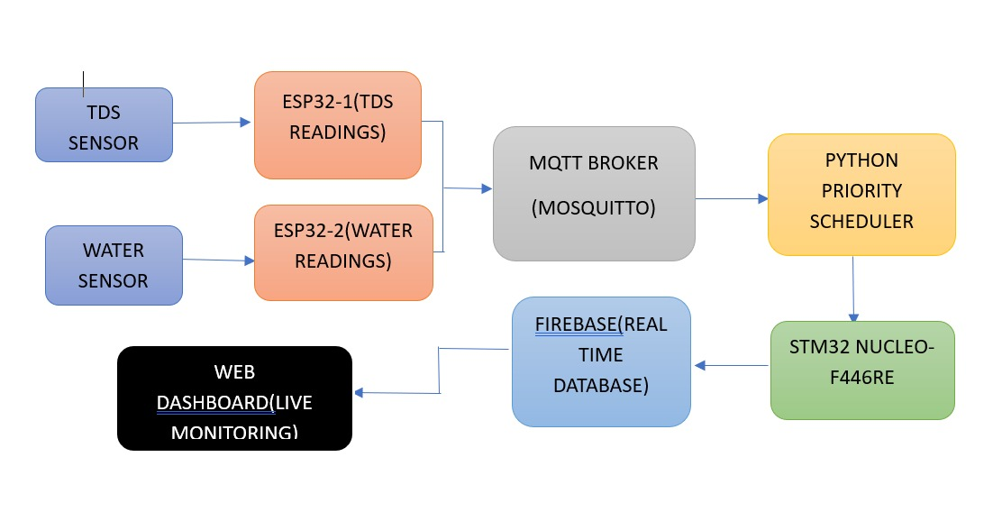

Fig: 6.1 Proposed project block diagram

SOFTWARE AND HARDWARE USED:
CODE:
1. ESP32-1 — TDS Sensor + MQTT
File name: ESP32_TDS.py
import network
import time
from machine import ADC, Pin
from umqtt.simple import MQTTClient

WIFI_SSID = "Esp32"
WIFI_PASSWORD = "YOUR_WIFI_PASSWORD"
BROKER = "10.60.111.70"

sensor = ADC(Pin(34))
sensor.atten(ADC.ATTN_11DB)
sensor.width(ADC.WIDTH_12BIT)

wifi = network.WLAN(network.STA_IF)
wifi.active(True)
wifi.connect(WIFI_SSID, WIFI_PASSWORD)

while not wifi.isconnected():
print("Connecting to WiFi...")
time.sleep(1)

print("WiFi connected:", wifi.ifconfig())

client = MQTTClient("TDS_ESP32", BROKER, port=1883)
client.connect()
print("MQTT connected")

while True:
value = sensor.read()
print("TDS raw ADC:", value)

client.publish(
b"sensor/tds",
str(value).encode()
)

time.sleep(2)
2. ESP32-2 — Water Sensor + MQTT
File name: ESP32_Water.py
import network
import time
from machine import ADC, Pin
from umqtt.simple import MQTTClient

WIFI_SSID = "Esp32"
WIFI_PASSWORD = "YOUR_WIFI_PASSWORD"
BROKER = "10.60.111.70"

sensor = ADC(Pin(34))
sensor.atten(ADC.ATTN_11DB)
sensor.width(ADC.WIDTH_12BIT)

wifi = network.WLAN(network.STA_IF)
wifi.active(True)
wifi.connect(WIFI_SSID, WIFI_PASSWORD)

while not wifi.isconnected():
print("Connecting to WiFi...")
time.sleep(1)

print("WiFi connected:", wifi.ifconfig())

client = MQTTClient("Water_ESP32", BROKER, port=1883)
client.connect()
print("MQTT connected")

while True:
value = sensor.read()
print("Water sensor raw ADC:", value)

client.publish(
b"sensor/water2",
str(value).encode()
)

time.sleep(2)
3. Python — MQTT Priority Scheduler + STM32 UART
File name: python scheduler_1.py
import paho.mqtt.client as mqtt
import heapq
import time
import serial
import threading

BROKER = "10.60.111.70"
PORT = 1883

STM32_PORT = "COM7"
BAUD_RATE = 115200
BATCH_WAIT = 20

queue = []
counter = 0
processing = False
queue_lock = threading.Lock()

try:
stm32 = serial.Serial(
STM32_PORT,
BAUD_RATE,
timeout=5,
write_timeout=5
)
time.sleep(2)
stm32.reset_input_buffer()
stm32.reset_output_buffer()
print("STM32 UART Connected:", STM32_PORT)
except (serial.SerialException, OSError) as e:
stm32 = None
print("STM32 UART connection failed:", e)

def on_connect(client, userdata, flags, reason_code, properties):
if reason_code == 0:
print("Connected to MQTT Broker")
client.subscribe("sensor/tds", qos=1)
client.subscribe("sensor/water2", qos=1)
print("Subscribed to sensor topics")
print("Priority Scheduler Started")
else:
print("MQTT connection failed:", reason_code)

def on_message(client, userdata, msg):
global counter

topic = msg.topic
value = msg.payload.decode().strip()

try:
sensor_value = int(value)
except ValueError:
print("Invalid sensor value:", value)
return

if topic == "sensor/tds" and sensor_value >= 100:
priority = 1
status = "CRITICAL"
elif topic == "sensor/water2" and sensor_value >= 1:
priority = 1
status = "CRITICAL"
else:
priority = 2
status = "NORMAL"

with queue_lock:
counter += 1
heapq.heappush(
queue,
(priority, counter, topic, value, status)
)

print(
"RECEIVED:", topic,
"| Value:", value,
"| Status:", status,
"| Priority:", priority
)

def process_queue():
global processing

with queue_lock:
if processing or not queue:
return

processing = True
batch = []

while queue:
batch.append(heapq.heappop(queue))

try:
print("--- BATCH PROCESSING STARTED ---")

if stm32 is None or not stm32.is_open:
print("STM32 UART unavailable.")
return

stm32.reset_input_buffer()

for priority, count, topic, value, status in batch:
print("SENDING:", status, "|", topic, "|", value)

stm32.write((status + "\r\n").encode("ascii"))
stm32.flush()

acknowledged = False

while not acknowledged:
response = (
stm32.readline()
.decode("ascii", errors="replace")
.strip()
)

if not response:
print("STM32 ACK TIMEOUT:", status)
return

print("STM32 RESPONSE:", response)

if "STM32 QUEUED:" in response:
acknowledged = True

stm32.write(b"END\r\n")
stm32.flush()

print("--- STM32 PRIORITY RESULTS ---")

while True:
response = (
stm32.readline()
.decode("ascii", errors="replace")
.strip()
)

if not response:
print("STM32 RESPONSE TIMEOUT")
break

print("STM32 RESPONSE:", response)

if "STM32 PRIORITY PROCESSING END" in response:
break

print("--- BATCH PROCESSING COMPLETED ---")

except (serial.SerialException, OSError) as e:
print("STM32 UART error:", e)

finally:
with queue_lock:
processing = False

def batch_worker():
while True:
time.sleep(BATCH_WAIT)
process_queue()

client = mqtt.Client(
callback_api_version=mqtt.CallbackAPIVersion.VERSION2
)

client.on_connect = on_connect
client.on_message = on_message

threading.Thread(
target=batch_worker,
daemon=True
).start()

try:
print("Connecting to MQTT Broker:", BROKER)
client.connect(BROKER, PORT, 60)
client.loop_forever()

except KeyboardInterrupt:
print("Scheduler stopped by user.")

except Exception as e:
print("MQTT error:", e)

finally:
try:
client.disconnect()
except Exception:
pass

if stm32 is not None and stm32.is_open:
stm32.close()
print("STM32 UART disconnected.")
4. STM32 — scheduler.h
#ifndef SCHEDULER_H
#define SCHEDULER_H

#include <stdint.h>

#define MAX_MESSAGES 10

typedef enum
{
PRIORITY_CRITICAL = 1,
PRIORITY_NORMAL = 2
} MessagePriority;

typedef struct
{
uint8_t messageId;
MessagePriority priority;
uint32_t arrivalTime;
} ScheduledMessage;

void Scheduler_Init(void);

int Scheduler_AddMessage(
uint8_t id,
MessagePriority priority
);

int Scheduler_GetNextMessage(
ScheduledMessage *message
);

#endif
5. STM32 — scheduler.c
#include "scheduler.h"

static ScheduledMessage queue[MAX_MESSAGES];
static uint8_t messageCount = 0;

void Scheduler_Init(void)
{
messageCount = 0;
}

int Scheduler_AddMessage(
uint8_t id,
MessagePriority priority
)
{
if (messageCount >= MAX_MESSAGES)
{
return 0;
}

ScheduledMessage newMessage;

newMessage.messageId = id;
newMessage.priority = priority;
newMessage.arrivalTime = messageCount;

uint8_t i = messageCount;

while (i > 0 &&
queue[i - 1].priority > newMessage.priority)
{
queue[i] = queue[i - 1];
i--;
}

queue[i] = newMessage;
messageCount++;

return 1;
}

int Scheduler_GetNextMessage(
ScheduledMessage *message
)
{
if (messageCount == 0 || message == 0)
{
return 0;
}

*message = queue[0];

for (uint8_t i = 1; i < messageCount; i++)
{
queue[i - 1] = queue[i];
}

messageCount--;

return 1;
}

1.2 Hardware Requriments:

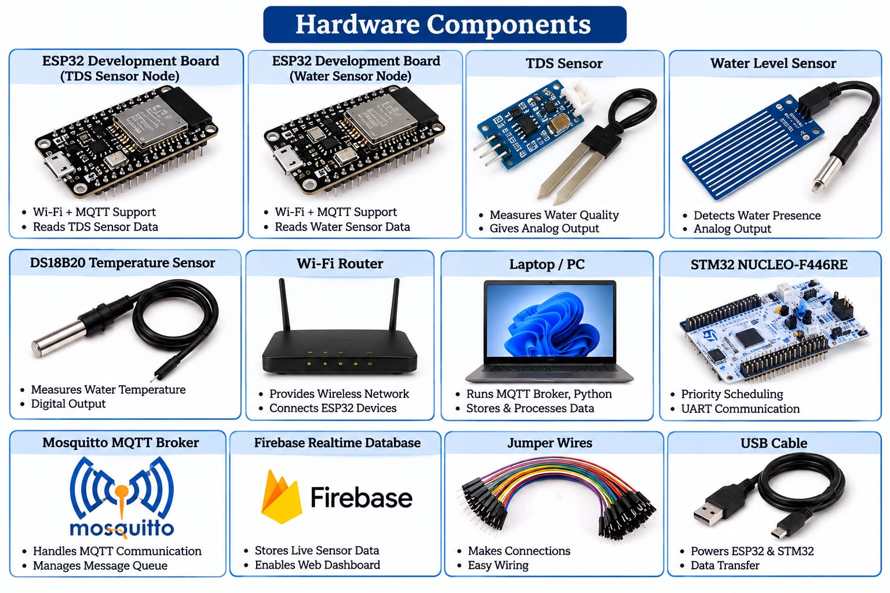

Hardware Components
1. ESP32 Development Board

The ESP32 is a microcontroller board with built-in Wi-Fi connectivity. In this project, two ESP32 boards are used to collect data from the TDS sensor and water sensor and transmit the sensor readings to the MQTT broker through Wi-Fi.

2. TDS Sensor

The Total Dissolved Solids (TDS) sensor is used to measure the approximate concentration of dissolved substances in water. It provides sensor readings to ESP32, which publishes the data using the MQTT protocol.

3. Water Sensor

The water sensor detects the presence or level of water, depending on the sensor type. It provides readings to the second ESP32, which sends the data to the MQTT broker for monitoring and priority classification.

4. STM32 NUCLEO-F446RE Development Board

The STM32 NUCLEO-F446RE is used to implement and demonstrate priority-based message scheduling. It receives messages from the Python scheduler through UART communication and processes critical-priority messages before normal-priority messages.

5 Laptop / Personal Computer

The laptop runs the Mosquitto MQTT broker and Python-based priority scheduler. It receives MQTT messages, classifies them according to priority, and communicates with the STM32 board.

6 Wi-Fi Hotspot / Router

The Wi-Fi hotspot provides wireless network connectivity between the ESP32 sensor nodes and the laptop running the MQTT broker.

7. USB Cable

USB cables are used to power the development boards, upload programs, and establish serial communication between the STM32 board and the laptop.

8 Jumper Wires

Jumper wires connect the sensors to the ESP32 boards and provide the required signal and power connections.

CHAPTER-7

SIMULATION AND RESULTS ANALYSIS
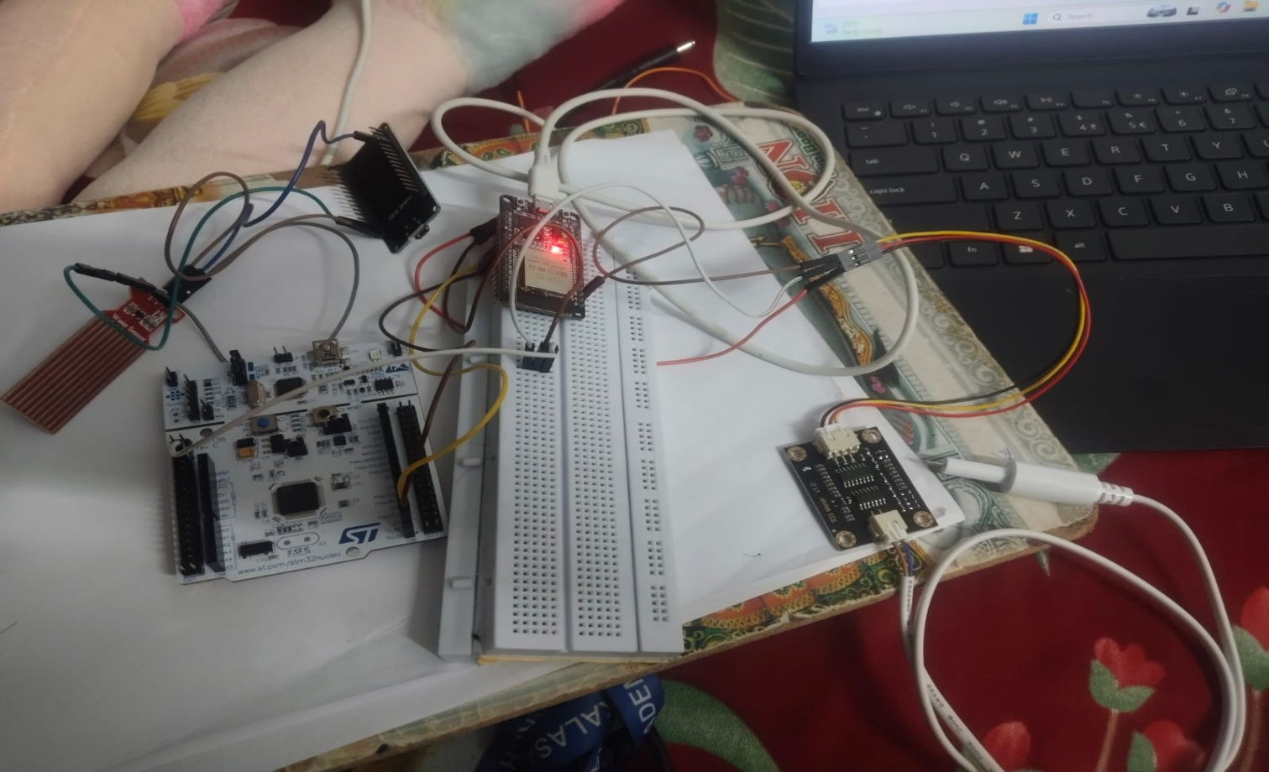
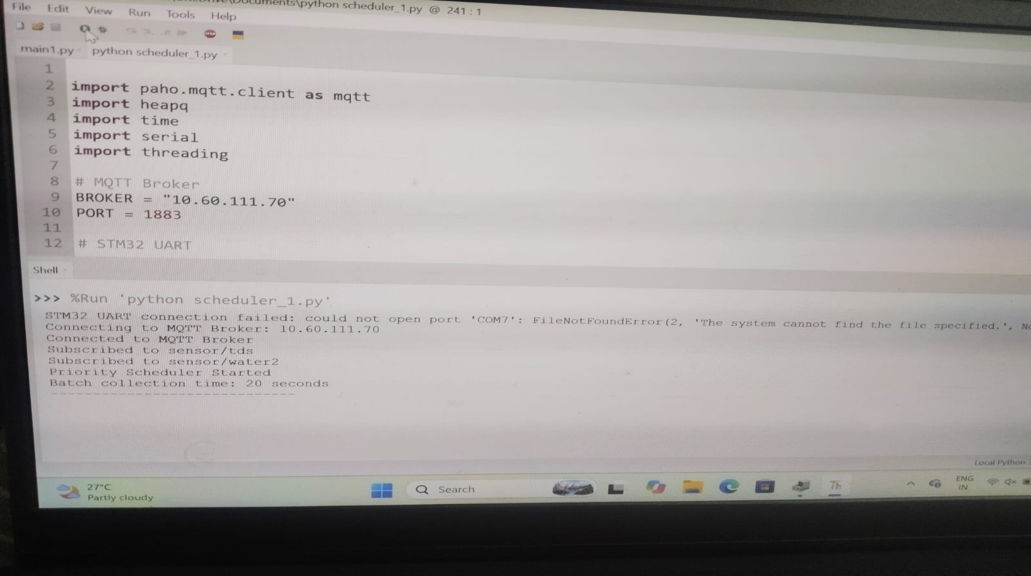

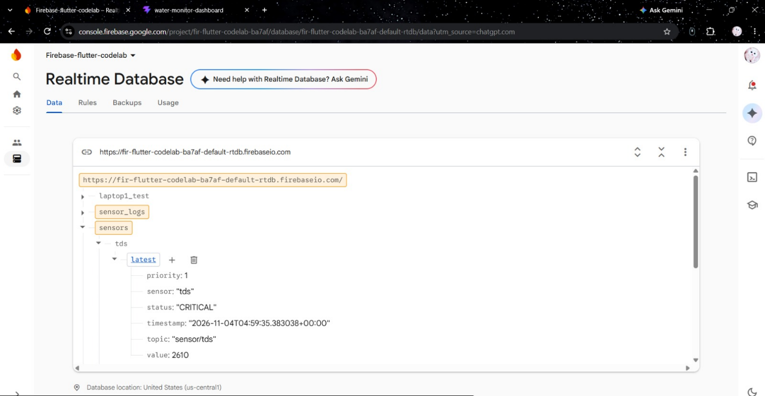
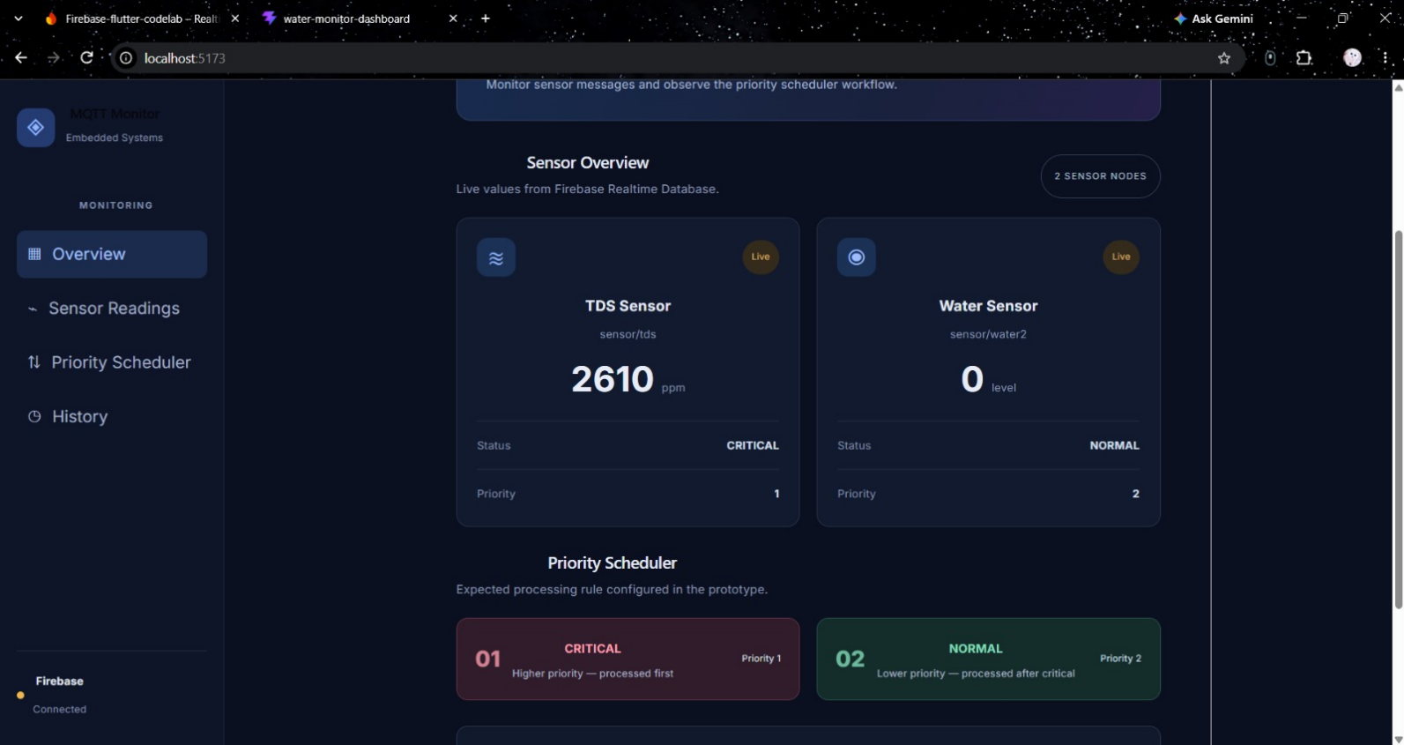

Result Analysis:

Test Environment
The prototype test setup consists of two ESP32 sensor nodes, a laptop-hosted Mosquitto broker, a Python subscriber/scheduler process, a NUCLEO-F446RE board connected through a serial port, Firebase Realtime Database and a React/Vite dashboard. The reported UART settings are 115200 baud on COM7.

Observed Results
The team confirmed that the dashboard displays live TDS and water-sensor values, sensor logs, priority scheduler information and action values. The team also confirmed that Firebase updates are being received. These are reported implementation observations, not independently measured performance benchmarks.

Test item | Observation | Interpretation
TDS topic | Messages received on sensor/tds and Firebase upload messages observed. | The TDS data path is functioning in the reported setup.
Water topic | Messages received on sensor/water2 and Firebase upload messages observed. | The water-sensor data path is functioning in the reported setup.
Priority field | CRITICAL / priority 1 and NORMAL / priority 2 appear in the application data and dashboard. | Priority classification and display are implemented.
STM32 response | Logs include STM32 QUEUED, STM32 QUEUE FULL and ACK TIMEOUT. | UART exchange is present, but reliable acceptance under load needs improvement.
Dashboard processing order | The current overview does not show actual STM32 processing order or ACK history. | End-to-end deterministic execution is not yet proven by the dashboard.

Interpretation
The results show that the system can collect data from two MQTT topics, classify the readings using configured rules, upload data to Firebase and present the resulting information on a dashboard. The serial logs show that messages can reach the STM32 interface and receive responses. However, repeated transmission also produces queue-full and acknowledgement-timeout events. This means the embedded receiving queue and acknowledgement protocol require further work before the system can be described as consistently reliable.

Limitations
    - The threshold values are prototype values and are not validated measurement standards.
    - The STM32 receives status strings rather than the raw sensor readings in the current reported design.
    - Queue-full and acknowledgement-timeout events remain in the available logs.
    - The dashboard displays assigned priority information but does not yet prove the actual order of STM32 execution.
No measured latency distribution, throughput benchmark, packet-loss percentage or worst-case response-time result has been supplied

The hardware setup consists of:

CHAPTER-8 CONCLUSION AND FUTURE SCOPE

Conclusion
The project presents a prototype embedded IoT monitoring pipeline that combines two ESP32 sensor publishers, an MQTT broker, Python-based priority classification and scheduling, STM32 UART communication, Firebase storage and a React dashboard. The implemented software assigns priority 1 to readings classified as CRITICAL and priority 2 to readings classified as NORMAL according to the configured prototype thresholds. The team has confirmed that the live sensor values, logs, priority information and action values are visible through the dashboard.
The available logs also reveal an important engineering issue: the STM32 communication path can return queue-full responses and acknowledgement timeouts. For this reason, the current work demonstrates an integrated prototype and priority assignment, but it does not yet establish guaranteed deterministic execution at the STM32. The report makes this distinction explicit so that the final evaluation is based on verified behaviour.

Future Scope
    - Improve STM32 queue management and define a clear overflow policy.
    - Implement a robust UART frame format with message identifiers, acknowledgement matching and timeout recovery.
    - Record the STM32's accepted and completed message sequence so that actual processing order can be verified.
    - Measure end-to-end latency, queue waiting time, throughput and message loss under controlled load.
    - Define and test tie-breaking rules for messages with equal priority.
    - Validate sensor thresholds and add calibration information.
    - Add dashboard views for STM32 acknowledgement status, queue depth and measured scheduling metrics.
    - Secure broker communication and manage Firebase credentials through environment variables or a secure secret store.
    - Test the system under Wi-Fi interruption, broker restart and serial disconnection scenarios.

Final Remark

The prototype establishes the main communication and monitoring path. Completing the reliability and measurement work listed above will make the priority-scheduling contribution easier to demonstrate, evaluate and reproduce

CHAPTER-9

REFRENCES

- OASIS, “MQTT Version 3.1.1,” OASIS Standard, 2014. https://docs.oasis-open.org/mqtt/mqtt/v3.1.1/
- OASIS, “MQTT Version 5.0,” OASIS Standard, 2019. https://docs.oasis-open.org/mqtt/mqtt/v5.0/
- Eclipse Foundation, “Eclipse Mosquitto Documentation.” https://mosquitto.org/documentation/
- Python Software Foundation, “heapq — Heap queue algorithm.” https://docs.python.org/3/library/heapq.html
- STMicroelectronics, “STM32F446xx Datasheet and Reference Manual.” https://www.st.com/
- Google Firebase, “Firebase Realtime Database Documentation.” https://firebase.google.com/docs/database
- Firebase, “Firebase Admin SDK Documentation.” https://firebase.google.com/docs/admin/setup
- React, “React Documentation.” https://react.dev/learn
Vite, “Vite Documentation.” https://vite.dev/guide/

